CITY OF LOS ANGELES
HOLLYWOOD HILLS WEST NEIGHBORHOOD COUNCIL OFFICERS  PRESIDENT  ANASTASIA MANN  VICE-PRESIDENT  ORRIN FELDMAN  SECOND VICE PRESIDENT  JANE CROCKETT  SECRETARY  KATHY BAÑUELOS  TREASURER  MICHAEL P. MEYER | CALIFORNIA |  | HOLLYWOOD HILLS WEST NEIGHBORHOOD COUNCIL  C/O Department of Neighborhood Empowerment  3516 N. Broadway  Los Angeles, CA 90031  TELEPHONE: (213) 485-1588  FAX: (213) 485-1836  Toll Free 1 (866) LA HELPS
 | 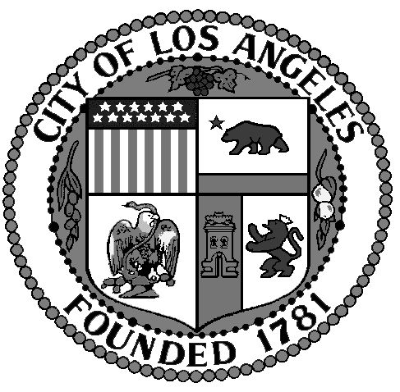

HOLLYWOOD HILLS WEST NEIGHBORHOOD COUNCIL

PLUM COMMITTEE MEETING
December 6, 2018
6:00 pm
Will and Ariel Durant Library Branch
7140 Sunset Blvd, Los Angeles, CA 90046

Directions: East of N. Fairfax Ave and West of N. La Brea Ave of Hollywood Blvd. Building is accessible and free parking is available behind the building.

HHWNC’s PLUM committee meeting will be held in the library’s community room, which is just off the lobby entrance. The meeting will start at 6 p.m. The meeting will be over at or before 8 p.m.

The PLUM committee consists of HHWNC’s 1st vice president, and the chairs of the following issue committees: transportation, business, infrastructure, housing and environment. In addition, the area chair for any agenda item’s site will have a vote on the PLUM committee for that agenda item. Four of the committee members must be present in order to establish a quorum to take any votes on agenda items.

The public is encouraged to attend and make public comments, but does not get to vote on agenda items. The public is requested to fill out a “Speaker Card” to address the committee on any item on the agenda prior to the committee taking action on an item. Public comments on agenda items will be heard when the item is considered. Comments from the public on non-agenda items within the committee’s subject matter jurisdiction will be heard during the public comment period for non-agenda items and, within the discretion of the committee’s presiding chair, when other agendized items are being considered. Public comment is limited to two (2) minutes per speaker unless waived by the presiding chair of the committee.

Agenda items may be taken out of order. Motions may be taken on any agenda item. Any action taken would then be referred to the Hollywood Hills West Neighborhood Council’s board (as a recommendation) for further consideration and action.

The library is located at the intersection of Sunset Blvd. and Detroit, which runs south from Sunset Blvd. Free parking is available in the library’s parking lot, which is entered from Detroit. The library is ADA accessible. If anyone has any disability related concerns, please email vicepresident@hhwnc.org for assistance ahead of the meeting.

THE AMERICAN WITH DISABILITIES ACT – As a covered entity under Title II of the Americans With Disabilities Act, the City of Los Angeles does not discriminate on the basis of disability and, upon request, will provide reasonable accommodations to ensure equal access to its programs, services and activities. Sign language interpreters, assistive listening devices, or other auxiliary aids and/or services may be provided upon request. To ensure availability of services, please make your request at least 3 business days (72 hours) prior to the meeting you wish to attend by contacting our neighborhood council’s coordinator, Lorenzo Briceno at (213) 978-1551 or email to Lorenzo.Briceno@lacity.org

PUBLIC ACCESS OF RECORDS – In compliance with Government Code section 54957.5, non-exempt writings that are distributed to a majority or all of the board in advance of a meeting may be viewed at our website: www.hhwnc.org or at the scheduled meeting. In addition, if you would like a copy of any record related to an item on the agenda, please contact Orrin Feldman, Board Vice President, at vicepresident@hhwnc.org.

ALL ITEMS LISTED ON THIS AGENDA ARE SUBJECT TO:
POSSIBLE ACTION, INCLUDING A BOARD MOTION AND
VOTING ON THE MOTION.

AGENDA

- Welcome, general comments and committee member introductions.

2. Consider approving draft minutes of prior meeting held on November 1, 2018.

3. 2005 N. Highland is the Hilton Garden Inn Los Angeles/Hollywood —— which is in HHWNC’s Area 4 and City Council District 4.

The hotel on this site was renovated and rebranded as a Hilton Garden Inn. The existing conditional use permit (CUP) to sell alcoholic beverages for on-site consumption expired/lapsed.
The LA Department of Building & Safety issued an order dated June 28, 2018, to cease servicing alcoholic beverages without a CUP.
RLJ-HGN Hollywood, LP owns the property. It has filed an application for a new CUP.
The application asks for CUP to allow the hotel serve alcoholic beverages for on-site consumption in the hotel’s restaurant, which has an outdoor terrace facing Highland Boulevard, in minibars in hotel guest rooms, and at two portable pool side bars in the pool area on the west/back side of the building. The applicant also is asking for approval to sell alcoholic beverages for off-site consumption to customers going to The Hollywood Bowl and Ford Theater events.
The proposed hours of operation in the original application were 6 a.m. to midnight for the dining rooms, but with alcohol service beginning at 11 a.m. The is an outdoor terrace area next to the dining rooms on the Highland Avenue side of the building, also was proposed to operate from 11 a.m. to midnight. The application proposed that the two portable bars adjacent to the swimming pool area, could operate from noon to 11 p.m.
The application also asked for a variance to be allowed to sell alcoholic beverages in an R4 zone.
No new construction and no live entertainment is being requested. There are speakers playing music in the pool area now, which would continue. Those speakers are turned off at 10 p.m., which is when the pool has been closing.
The Planning Department’s case no. is ZA-2018-5999-CUB-ZV. The CA CEQA no. is ENV-2018-6000-CE.
Steve Rawlings, the hotel’s representative, and Alfonso Torres, the hotel’s general manager, will be making the presentation on behalf of the hotel.

4. 6801 West Hollywood Boulevard is the Hollywood & Highland Shopping Center, which is in HHWNC’s Area 4 and City Council District 4.

Hard Rock Cafe is a tenant in the shopping center.
Hard Rock Cafe is applying to renew its CUP to sell a full line of alcoholic beverages for on-site consumption. The proposed hours of operation were from 7 a.m. to 2 a.m. daily.
Hard Rock Cafe also is seeking to change about a dozen conditions which are in the current CUP. Three of the proposed changes would be:
- to allow karaoke. No karaoke is allowed now.
- to expand the dance floor up to 4,680 square feet. Now, the dance floor accommodates about 20 dancing patrons. The restaurant has more than 20,000 square feet, and a maximum occupancy of 703 patrons.
(iii) to sell tickets to events which would be associated with 501(c)(3) non-profit organizations. No cover charges are allowed now.
The Planning Department’s case no. is ZA-2000-4320-CUB-CUX-PA10. The CA CEQA no. is ENV-2018-5950-CE.
Gary Benjamin will be making the presentation on behalf of Hard Rock Cafe.

5. Public comments on non-agendized items.

6 Adjournment.

